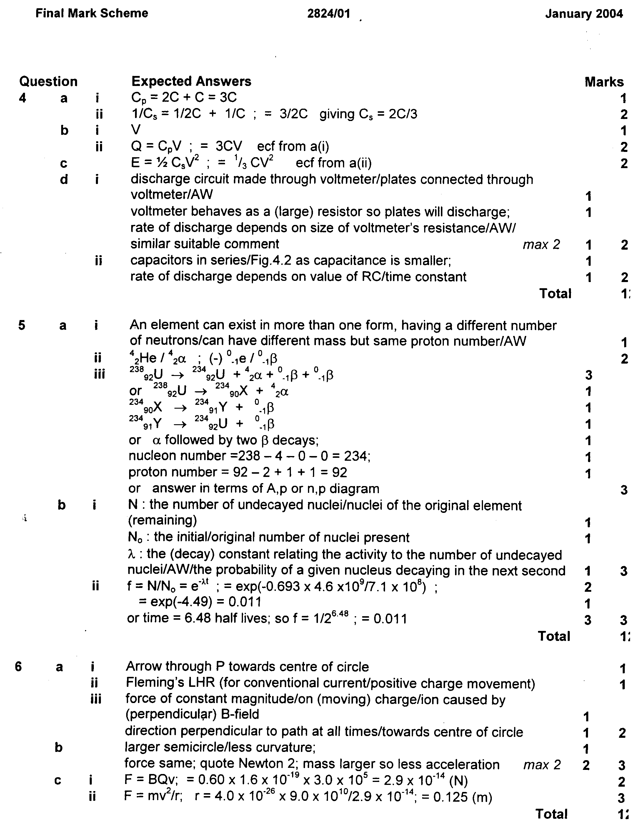
Radioactive decay (past paper Q)

2824 Jan., 2004, Q5

